Procjena i farmakoterapija bola
Prof. Dr D.Golić
Faculty of Medicine, Banjaluka
Logo of your
organization
Gradiška, 26.06.2020.

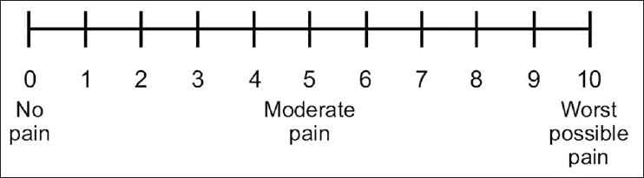
OPIJATI PODJELA 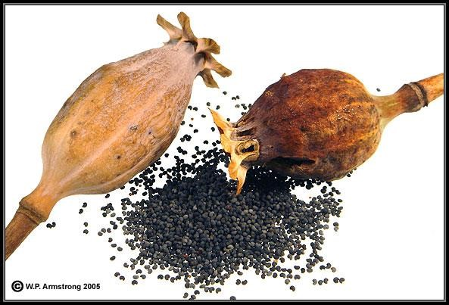
PRIRODNI
POLUSINTETSKI
SINTETSKI
MORFIN
CODEIN
PAPAVERIN
HEROIN
HIDROMORFIN
HIDROKODEIN
BUPRENORFIN
BUTORFANOL
TRAMADOL
METADON
PENTAZOCIN
FENTANYL
SUFENTANYL
ALFENTANYL
Receptori spregnuti sa proteinom G pons, amigdale, olfaktorni bulbus, kora, PNSdelta (δ₁ i δ₂), DOP, OP₁ enkefalin
40% homologni receptorima za somatostatin analgezija, antidepresija, zavisnost endorfin

Receptori za endogene opioide: kapa (κ₁, κ₂, κ₃), KOP, OP₂ dinorfin
Endorfin, dinorfin, enkefalin, endomorfin, hipotalamus, periakvaduktna siva masa
nociceptin analgezija, sedacija, disforija, mioza
mi (μ₁, μ₂, μ₃), MOP, OP₃ morfin
MS, MO, kora, talamus, periakvaduktna siva
masa, PNS, GIT β endorfin
μ₁ analgezija, zavisnost endomorfin
μ₂ euforija, zavisnost, mioza enkefalin μ₃ nepoznata dinorfin
receptori za nociceptin (ORL₁), NOP, OP₄
Nociceptin kora, hipotalamus, hipokampus, amigdale, MS,
(orphanin FQ) anksioznost, depresija, apetit…
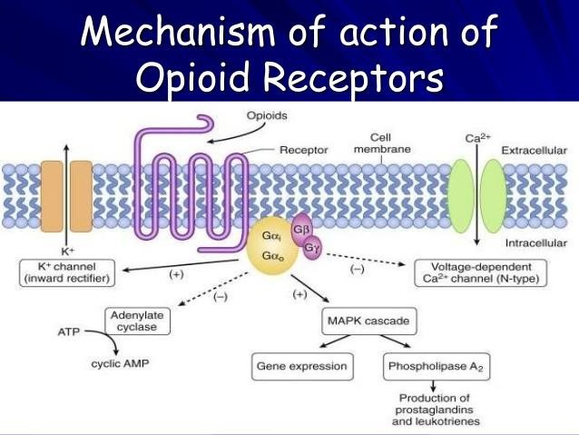
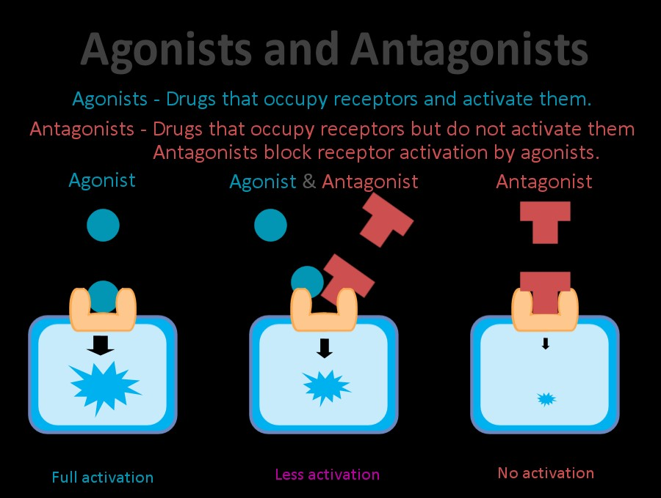
Uglavnom agonisti μ receptora, ali djeluju i na druge receptore _{Agonist na κ receptore,}
⊕
⊕
⊕
^{Morphine} sa djelimičnom antagonist. djelov.
^{Heroin} na μ receptore Codeine Pentazocine

Fentanyl
μ opioidni κ opioidni 
receptor receptor opioidni
Analgezija Analgezija Analgezijareceptor
Respiratorna depresija Sedacija
Euforija/sedacija Mioza
Psihička zavisnost

Smanjnje GI motiliteta Antagonist djeluje na μ, κ,  receptore
Mioza Naloxone Naltrexone

VRLO JAKI OPIOIDI0,05-0,09 | JAČINA
Sufentanyl | 1000
Remifentanyl | 200
Fentanyl | 100-300
Alfentanyl | 40-50
Buprenorfin | 10-40
JAKI OPIOIDI
Butorfanol | 8-11
Hidromofon | 7-10
Metadon | 1,5
Morfin | 1
SLABI
Kodein | 0,3
Petidin | 0,2
VEOMA SLABI  Project number: 585927-EPP-1-2017-1-RS | -EPPKA2-CBHE-JP (2017 – 3109 / 001 – 001)
Tramadol  "This project has been funded with support from the European Commission. This publication reflects the views only of the auth | 0,05-0,09 _{or,}
and the Commission cannot
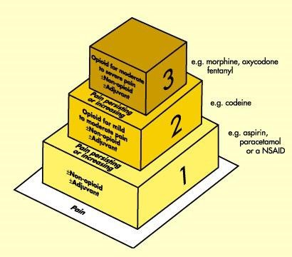

Analgesia – Side effect
●The harder we “push” with single mode analgesia, the greater the degree of side-effects
Acute pain

Acute pain presents most often with a clear cause, rela Acute pain is often accompanied by observable objecti increased pulse rate increased blood pressure
Non-verbal signs and symptoms such as facial expressions and

Pain assesment
Initial Pain Assessment should include:
Location(s)
Intensity
Sensory quality
Alleviating and aggravating factors

Any new onset of pain requires a new comprehensive p
PAIN REASSAMENT

Every 8 hours minimally Following the administration of pain medications to de
IV within 15 mins of administration
PO/IM/SC within 1 hour of administration
MULTIMODAL ANALGESIA

This term describes the use of multiple modalities that
Decreased dependence on single modality agents decreases the
May include
Pharmacological (opioids, NSAIDS, gabapentanoids)
Relaxation techniques (biofeedback, deep breathing) Regional analgesia (nerve blocks, epidural catheters)
Prescribing Responsible Opioid

Assess risk for opioid abuse or diversion prior to prescr Risk factors for misuse or abuse of opioids include the
Males between 18 and 45.
A personal history of substance abuse
A family history of substance abuse
A personal history of preadolescent sexual abuse
A personal history of psychological disease (depression, anxiet

OPIOID SELECTION
Use the lowest effective dose
Prescribe short durations for acute pain
Use immediate release when starting
World Health Organization (WHO)
●3- Step Ladder approach to pain management
Step 1- Mild Pain (1-3/10)
Nonopioid
Add adjuvant analgesic agent
(i.e.) Ice, heat

WHO
Step 2 Mild to moderate pain (4-7/10)
This step builds on step 1
Treat with opioid combination drug
(hydrocodone/acetaminophen)
Watch ceiling effect of adjuvant drug Peds are dosed by weight
Watch special needs patients/elderlyProject number: 585927-EPP-1-2017-1-RS-EPPKA2-CBHE-JP (2017 –

WHO
Step 3- Severe pain (8-10/10)
Use opioids
Add adjuvant (i.e.)anti-anxiety,anti-emetics, muscle relax
Start with short acting opioids to determine pain relief, bre
Switch to long acting use equianalgesic dosing chart for c

POINT TO REMEMBER
The pain intensity determines the step at which to begin. Opioids are the only group of analgesics with no ceiling o Most opioid side effects resolve within a few days.
d
Exception>>>>Constipation-- need to write for this imme Commonly used first line opioids
Codeine
Morphine
Hydromorphone
Oxycodone
Share the following characteristics
Half-life of immediate release preparations is 2 to 4 hou
Duration of analgesic effect between 4 to 5 hours when
Sustained release formulations have duration of analge

MORPHYNE
Onset: 15 to 60 minutes
Peak Effect: 30 minutes to 1 hr
Half Life: 1.5 to 2 hr
IV: 0.05 to 0.1 mg/kg
5 minutes prior to procedure; max: 15 mg/dose
